To Our visitors

Welcome to the Church of Christ Middletown. We are truly blessed by your presence. We thank God for your decision to come and be with us and hope that you will come and visit with us again on your next earliest opportunity. May the praise, the preaching, and the prayers in today’s worship give you joy and confidence to face the week ahead.
COCMT Announcements:
‘‘‘‘‘‘‘‘‘‘‘‘‘‘‘‘‘‘‘‘‘‘‘‘‘‘‘‘‘‘‘‘‘‘‘‘‘‘‘‘‘‘‘‘‘‘‘‘‘‘‘‘‘‘‘‘‘‘‘‘‘‘‘‘‘‘‘‘‘‘‘‘‘‘.

Prison Ministry: The Prison Ministry s looking for additional volunteers. Please see Brother Kevin or Brother Leon if you are interested. Welcome Sister Angela to the Women’s ministry.

Ladies Prayer Meetings: Every Friday on Zoom at 7:00 P.M. Meeting ID: 482 723 8178 Passcode: w7atWv. Whatsapp group: https://chat.whatsapp.com/KEuU4WlRdCS1nzMpPAvJuD

Men’s Bible Study (Updated info): Every Thursday night at 7PM Bro Frank Watson host men’s Bible study Via ZOOM
Meeting ID: 7183518263
Passcode: 1714
Call Number 415-762-9988

Prayer Requests: Please email prayer request to middletowncofc@gmail.com. This will help with posing requests in the bulletin. Please submit requests by Thursday evening in order to be posted on Sunday’s Bulletin.

Remember to PUSH: Pray Until Something Happens

‘‘‘‘‘‘‘‘‘‘‘‘‘‘‘‘‘‘‘‘‘‘‘‘‘‘‘‘‘‘‘‘‘‘‘‘‘‘‘‘‘‘‘‘‘‘‘‘‘‘‘‘‘‘‘‘‘‘‘‘‘‘‘‘‘‘‘‘‘‘‘‘‘‘‘‘‘‘‘‘‘‘‘‘‘‘‘‘
Birthdays; Anniversaries
(Please submit all announcements to Brother Ken by Thursday.)

Brother Ebenezer------------------------------------11/11
Zechariah----------------------------------------------11/16
Brother Grant----------------------------------------11/24
Brother Rod Sr.--------------------------------------11/24
Brother and Sister Bernard (Anniversary)-----11/24

Website: middletowncofc.com

Order of Worship
November 03rd, 2024 11:00 A.M.

Song Leader Bro. Ebenezer Jackson Opening Prayer Bro. Rod Carroll Sr.
Communion / Offering Bro. Paul King
Sermon Bro. Ken Douglas
Announcements/ Prayer requests Bro. Harold Grant
Closing Prayer Bro. Leon Brown

Sunday Morning Bible Study 10/27/24 12

Sunday Morning Worship 10/27/24 29

Contribution 10/27/24 $480

Weekly Budget $ 750.00

What Must I Do To Be Saved?
Hear - the Gospel Rom. 10:17
Believe - the Gospel Mark 16:15-16
Repent - of Sins Acts 17:30
Confess – Christ Romans 10:9-10
Be Baptized - for the remission of sins Acts 2:38
Remain – Faithful in your Christian walk Rev. 2: 10

For Bible correspondence course and in home Bible study please contact
Bro. Kenneth Douglas (Minister) Ph: (302) 463-4644

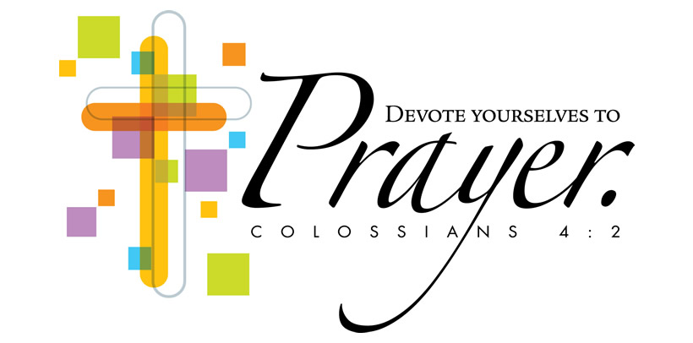
Prayer Requests/Responses:

- Continue to pray for our Military Men and Women, Police, and Firefighters.
- Brother Mike’s Sister-in-Law has tumors
- Sister Sharon’s Nephew has cancer
- Gerald and Lola White
- Sister Karen’s Brother Randy and his health
- Brother Grant’s Brother-in-Law Frank
- Charlene (Brother Rod’s Sister) had mini strokes.
- Sister Sharon is home. Pray for her recovery from surgery.
- Brother Ulysses has been diagnosed with cancer.
- Brother Ken and his Job.
- Sister Shannon and her new job.
- Sister Desiree for Peace, Health, and Wealth.
- Rod Jr. and those that are working with him.
- Sister Leo’s Sister Oralia is having health concerns again.
- Elijah on a new job opportunity.
- Brother Ebenezer for wisdom.

CHURCH OF CHRIST MIDDLETOWN
128 Patriot Dr. Suite #10 Middletown, Delaware 19709.
(302) 463-4644
Website: middletowncofc.com

2024 Annual Theme “Shine Christ’s Light”

"In the same way, let your light shine before others, so that they may see your good works and give glory to your Father who is in heaven." — Matthew 5:16

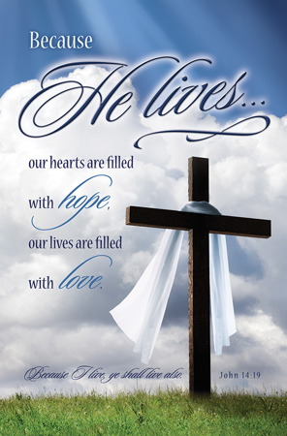

Schedule of Services
Sunday Bible School…………………………………………………..10:00 A.M.
Sunday Morning Worship…………………………………………..11:00 A.M.
Sunday Evening Worship (Last Sunday of the Month)……Postponed.
Tuesday Night Bible Class…………………………………………..Postponed.

Kenneth W. Douglas, Minister
(302) 463-4644

CHURCH OF CHRIST MIDDLETOWN
128 Patriot Dr. Suite #10 Middletown, Delaware 19709.
PH. (302) 463-4644

Mailing Address: P.O. BOX 626 MIDDLETOWN, DELAWARE 19709

Conversations will not be cancelled.
Relationships will not be cancelled.
Love will not be cancelled.
Songs will not be cancelled.
Reading will not be cancelled.
Self-Care will not be cancelled.
Hope will not be cancelled.

"Therefore encourage one another and build each other up, just as in fact you are doing.” ~ 1 Thessalonians 5:11

*We often say grace is “unmerited favor,” and it is. But it’s easier to understand it as God acting in our life to do what we cannot do on our own.

